This product is simple and does not use the plugin. As you can see, the price is shown with and without tax.

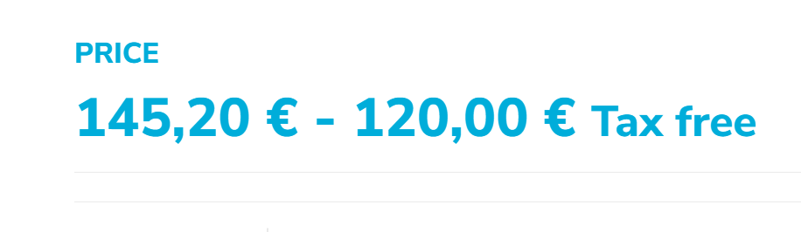
When I use the plugin, the price without tax option disappears, even if I select an optional item. This creates some confusion for the customer, since the prices of the optional products are correct with and without the tax.
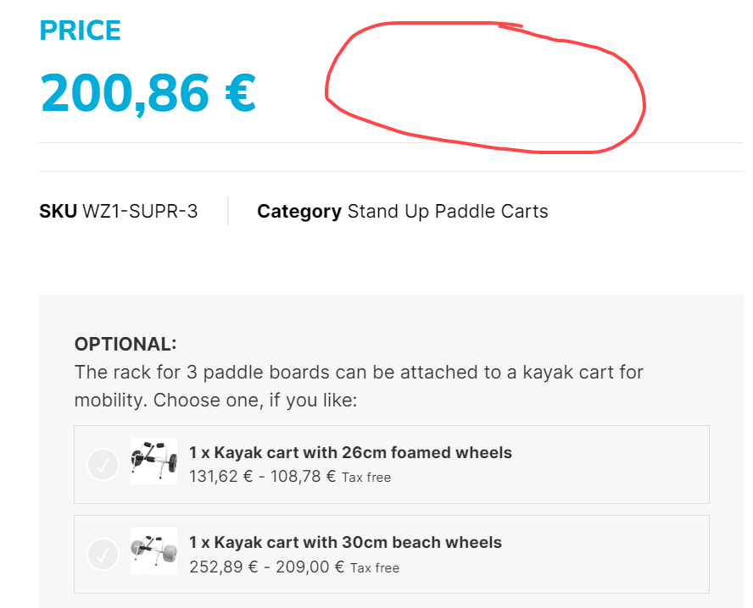

And something similar happens to me in the shopping cart. If I add the product without options, it shows me the correct price without the tax, but if I add it with one of the options, it shows me the price with taxes, which creates confusion, although the total final price is correct.
